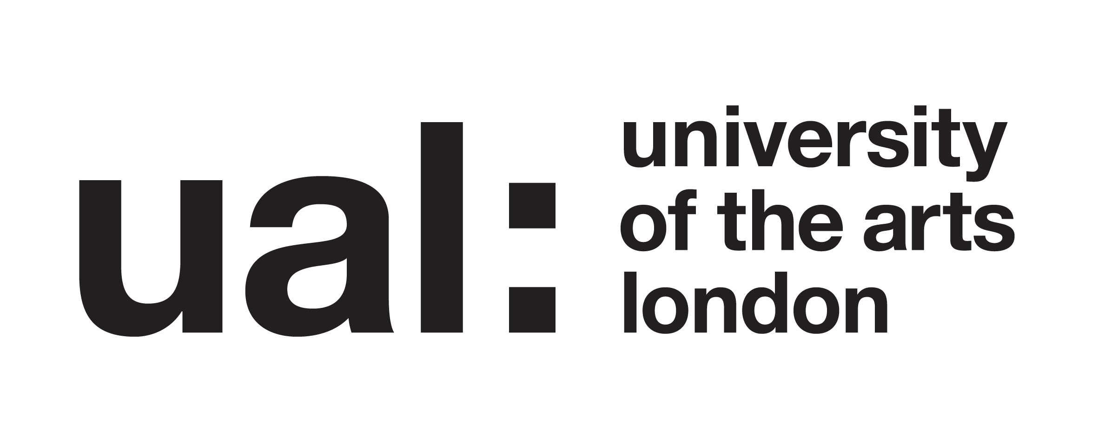

LAB: Drawing for Design / Wednesday 26th November 2025

Participant Information Sheet

About this study

Welcome. This study is part of my research project on the PgCert Academic Practice in Art, Design and Communication at UAL.

I am conducting an enquiry into the role of drawing in design education. I am interested in undergraduate students’ expectations, experiences and reflections on the use of drawing as part of their year one studies on BA(Hons) Graphic Media Design at London College of Communication.

My research will document, evaluate and analyse: students’ previous experiences of drawing prior to university, their current use of drawing in their studies at LCC, plus the creative outcomes and discussions as per the workshop activivites.

The research methods and approaches I use will be qualitative: combining participant observation and responsive evaluation approaches: consisting of a brief introductory questionnaire, hands-on collaborative drawing activities, focus group discussions and feedback. Written, spoken and visual responses will be analysed thematically.

What does it mean to take part?

As a participant you are consenting to take part in the LAB: Drawing for Design workshop. The workshop will take place between 2-6pm on Wednesday 26th November 2025. The workshop activities will be documented via photography. Focus group discussions may be dictated and quoted. The collected visual and written data will be used as the basis for academic research and analysis only.

If you choose to take part, you will be free to withdraw your participation at any point and you will not be obliged to give any reason for deciding not to take part.

Please inform me if you wish not to be included in photographs.

Will my participation be kept confidential?

Your anonymity is very important. The information about you will be confidential to me, as the researcher. You will not be identified individually anywhere in the research. If I quote anything you have spoken, written or… drawn during the workshop, it will be made anonymous. An example might be: ‘Student A said ‘The project is…’.’

What will happen to the results of the research project?

Analysis from the questionnaire, workshop activity outputs and focus group discussion - including quotations from you - will contribute to my academic research project. Your words may also be used in academic reports, papers or conference presentations which may appear online.

Thank you for your helpful contribution and participation in this study.

Contact for further information:

Researcher:
Kelly Harrison, Lecturer in Communication Design, BA(Hons) Graphic Media Design, London College of Communication, University of the Arts London
Email: k.harrison@ lcc.arts.ac.uk

